**Program 1**

10/05/2021

**Aim:** Program to list the sub directories and files in a given

directory and also search for a file name.

**Algorithm:**

**Source Code:**

package packoops;

import java.io.File;

class Listfile {

public static void main(String[] args) {

File file = new File("C:\\Users\\jomin\\Desktop");

String[] fileList = file.list();

for(String str: fileList) {

System.out.println(str);

}

}

}

**Output:**

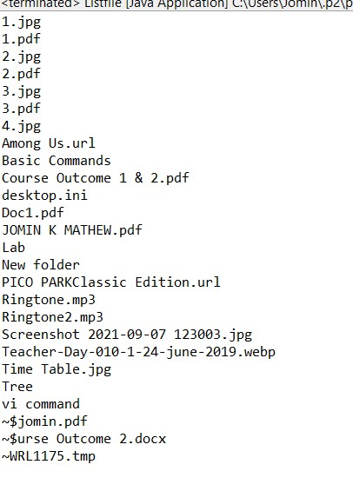

**Program 2**

10/05/2021

**Aim:** Write a program to write to a file, then read from the

file and display the contents on the console.

**Algorithm:**

**Source Code:**

import java.io.File;

import java.io.IOException;

import java.io.FileWriter;

import java.util.Scanner

public class write

{

public static void main(String[] args) {

try {

Scanner re=new Scanner(System.in);

FileWriter obj = new FileWriter("D:\\programming\\file.txt");

System.out.println("Write mode ON....." +

"");

String a= re.nextLine();

obj.write(a);

obj.close();

System.out.println("Successfully written");

File obk = new File("D:\\programming\\file.txt");

System.out.println("Read mode ON....." +

"");

Scanner reada=new Scanner(obk);

while(reada.hasNextLine()){

String data= reada.nextLine();

System.out.println(data);

}

reada.close();

} catch (IOException e) {

System.out.println("Error Occurred");

e.printStackTrace();

}

}

}

**Output:**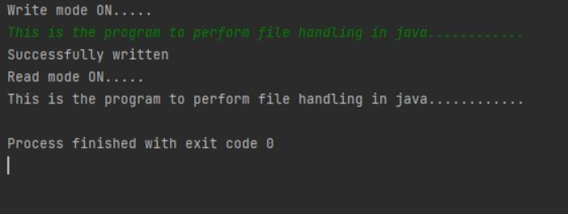

**Program 3**

10/05/2021

**Aim:** Write a program to copy one file to another.

**Algorithm:**

**Source Code:**

import java.io.*;

import java.util.*;

public class copy {

public static void main(String[] args) throws Exception{

Scanner re = new Scanner(System.in);

System.out.println("Enter the path of the source file");

String sc=re.next();

System.out.println("Enter the path of the destination file:");

String dc=re.next();

System.out.println("Copying........");

FileReader ra= new FileReader(sc);

FileWriter wr =new FileWriter(dc,true);

int c;

while((c= ra.read()) !=-1){

wr.write(c);

}

System.out.println("Copied........");

ra.close();

wr.close();

}

}

**Output:**

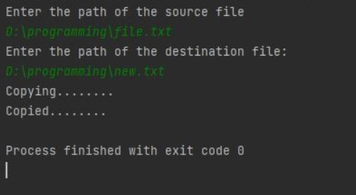

**Program 4**

10/05/2021

**Aim:** Write a program that reads from a file having integers.

Copy even numbers and odd numbers to separate files.

**Algorithm:**

**Source Code:**

import java.io.FileInputStream;

import java.io.FileOutputStream;

import java.io.IOException;

class evenodd {

public static void main(String[] args) throws IOException {

FileInputStream fr = new FileInputStream("D:\\MCA\\Sem 2\\oops lab\\Course Outcomes\\CO6\\prgrm4\\Numbers.txt");

FileOutputStream fw1 = new FileOutputStream("D:\\MCA\\Sem 2\\oops lab\\Course Outcomes\\CO6\\prgrm4\\Even Numbers.txt");

FileOutputStream fw2 = new FileOutputStream("D:\\MCA\\Sem 2\\oops lab\\Course Outcomes\\CO6\\prgrm4\\Odd Numbers.txt");

System.out.println("Even & Odd numbers copied to seperate files");

int i;

while((i=fr.read()) != -1)

{

if(i%2==00)

fw1.write(i);

else

fw2.write(i);

}

fr.close();

fw1.close();

fw2.close();

}

}

**Output:**

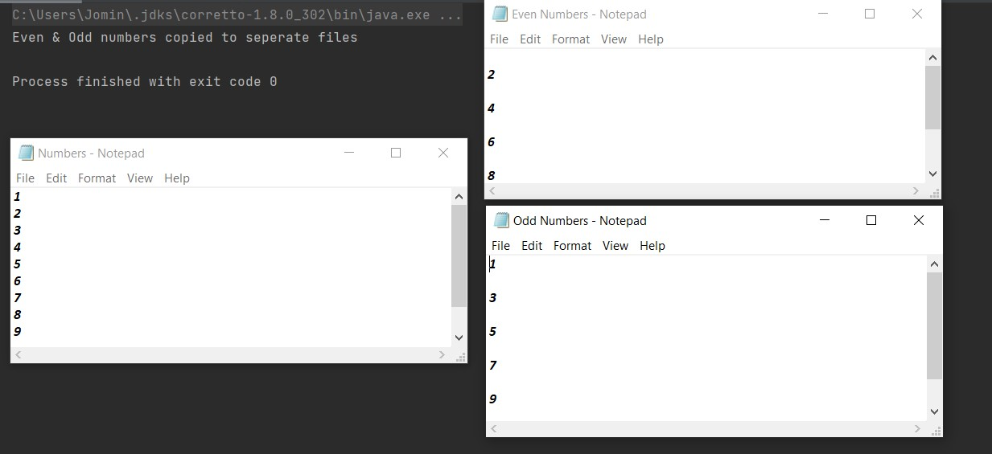

**Program 5**

10/05/2021

**Aim:** Client server communication using Socket – TCP/IP.

**Algorithm:**

**Source Code:**

*server.java*

import java.net.*;

import java.io.*;

class server {

public static void main(String[] args) throws Exception {

try {

ServerSocket ss = new ServerSocket(2665);

System.out.println("Server is waiting .....");

Socket s = ss.accept();

System.out.println("CONNECTION ESTABLISHED !!!");

InputStreamReader isr = new InputStreamReader(s.getInputStream());

BufferedReader br = new BufferedReader(isr);

String str = br.readLine();

System.out.println("Message from Client: "+str);

PrintWriter pw = new PrintWriter(s.getOutputStream(), true);

pw.println("Hello Client!!.");

pw.close();

}

catch(Exception e) {

System.out.println("An error occured.."+e);

}

}

}

*client.java*

import java.net.*;

import java.io.*

class client {

public static void main(String args[]) throws Exception{

try {

Socket s = new Socket ("localhost", 2665);

PrintWriter pw = new PrintWriter(s.getOutputStream(), true);

pw.println("Hello Server!!");

//Client is reading from its InputStream

InputStreamReader isr = new InputStreamReader(s.getInputStream());

BufferedReader br = new BufferedReader(isr);

String str= br.readLine();

System.out.println("Message from Server: "+str);

pw.close();

s.close();

}

catch(Exception e) {

System.out.println("An error occured..." +e);

}

}

}

**Output:**

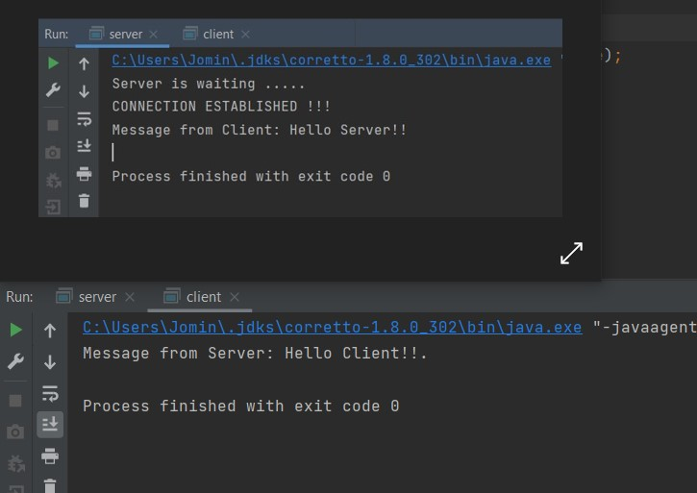

**Program 6**

10/05/2021

**Aim:** Client Server communication using DatagramSocket –

UD.

**Algorithm:**

**Source Code:**

*serverudp.java*

import java.io.*;

import java.net.*

public class serverudp {

public static void main(String[] args) throws IOException {

DatagramSocket server=new DatagramSocket(4220);

byte[] buf=new byte[256];

DatagramPacket packet=new DatagramPacket(buf,buf.length);

server.receive(packet);

String reply =new String(packet.getData());

System.out.println("\n Client Says : "+reply);

server.close();

}}

*clientudp.java*

import java.io.*;

import java.net.*;

public class clientudp {

public static void main(String[] args) throws IOException {

DatagramSocket client= new DatagramSocket();

InetAddress add=InetAddress.getByName("localhost");

String str ="Hello Server!!!";

byte[] bufBytes = str.getBytes();

DatagramPacket datagramPacket=new DatagramPacket(bufBytes,bufBytes.length,add,4220);

client.send(datagramPacket);

client.close();

}

}

**Output:**

